# Introduction Page

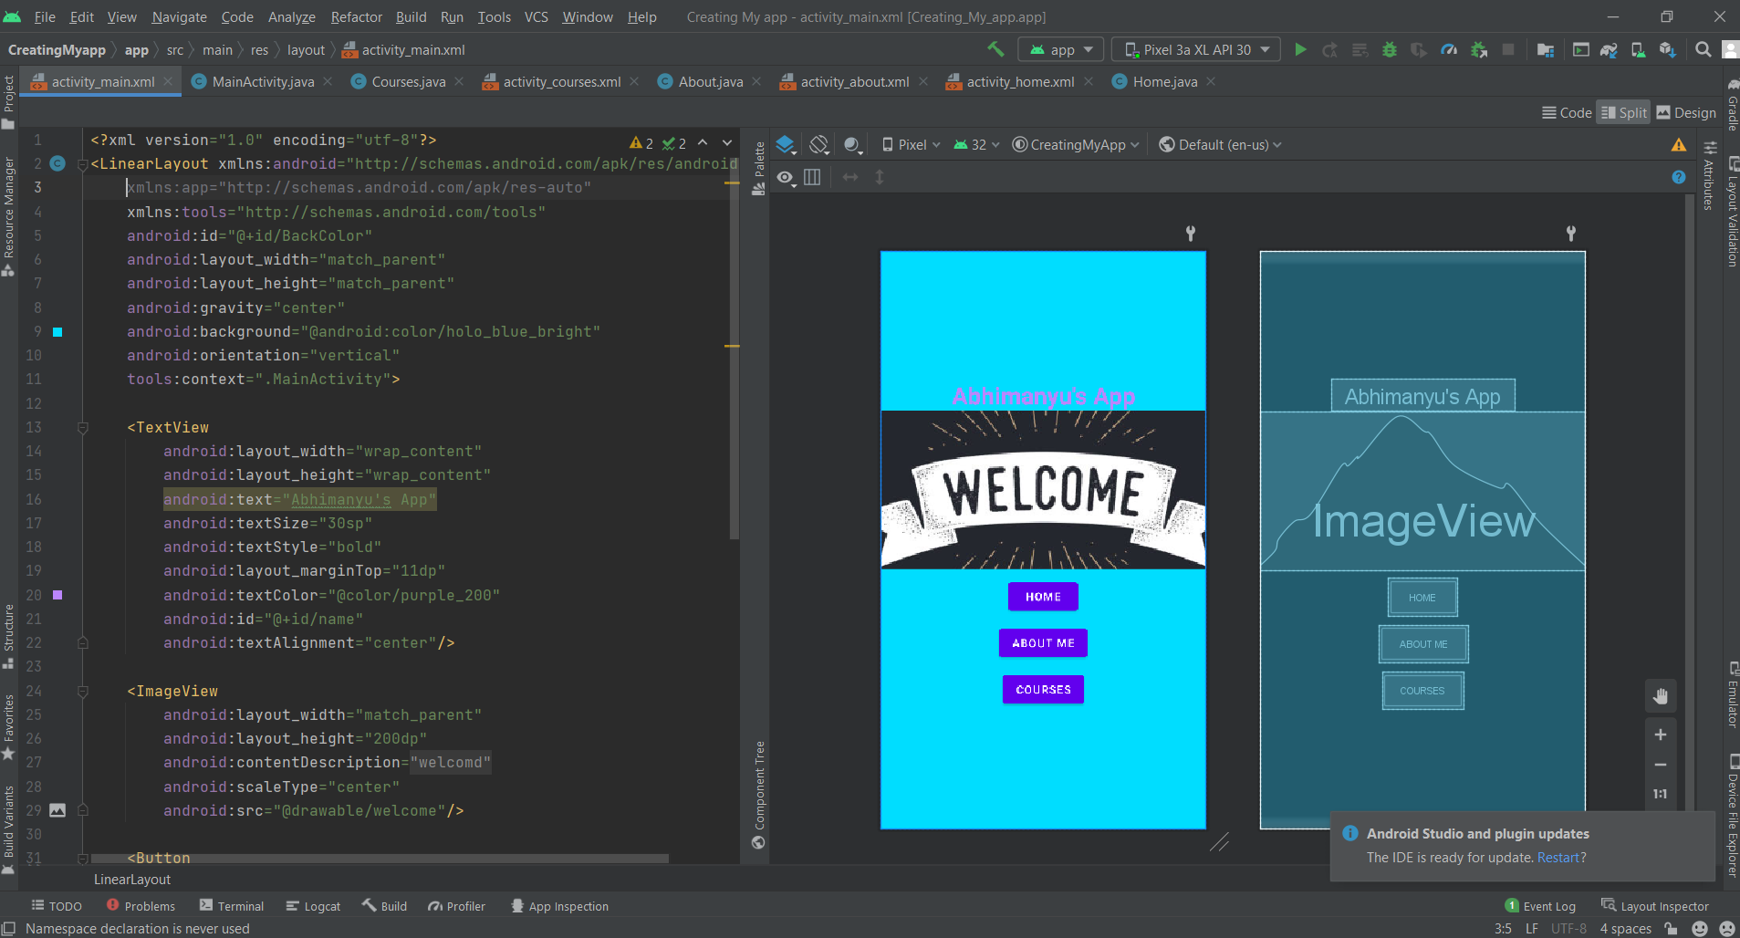

# Home

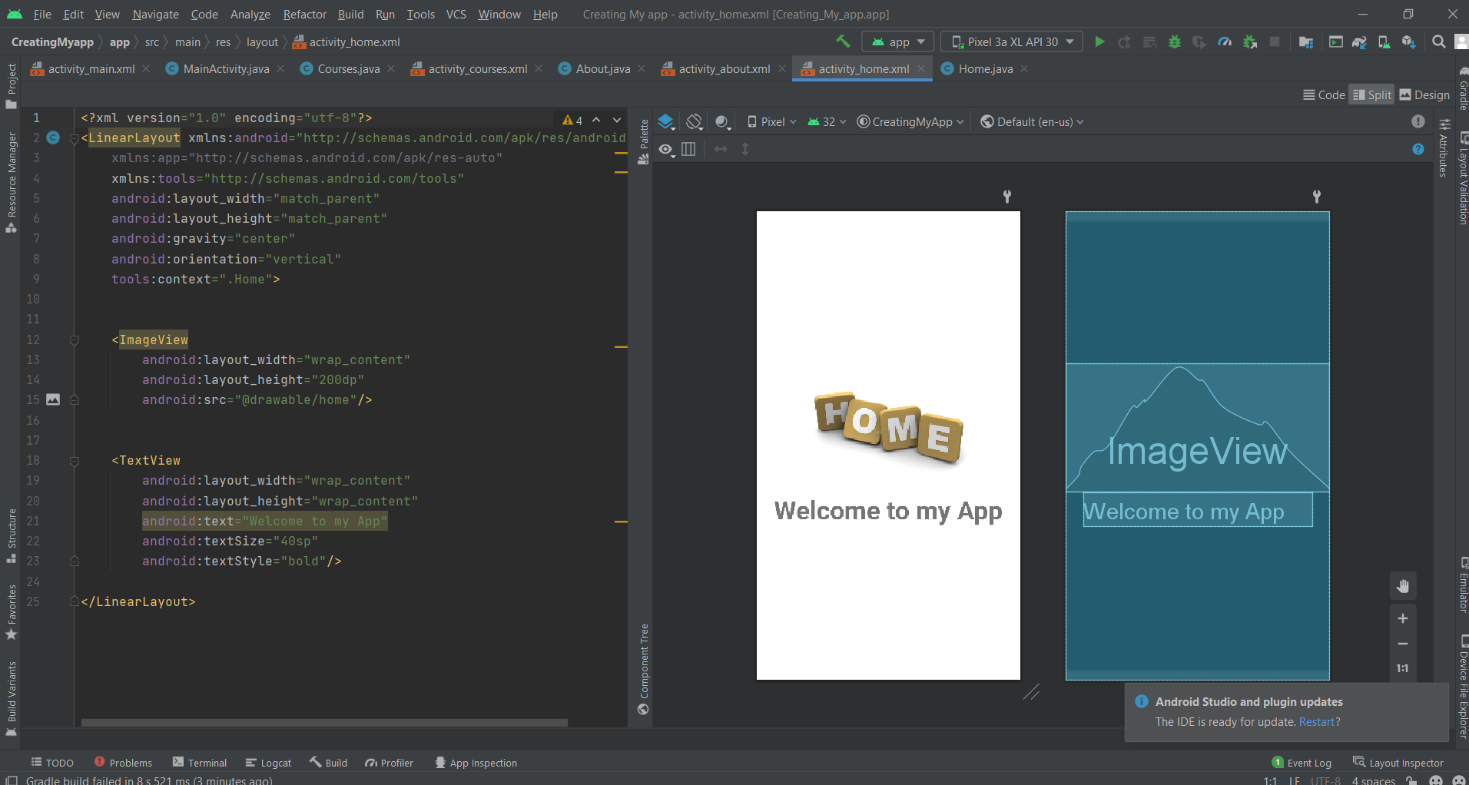

# About

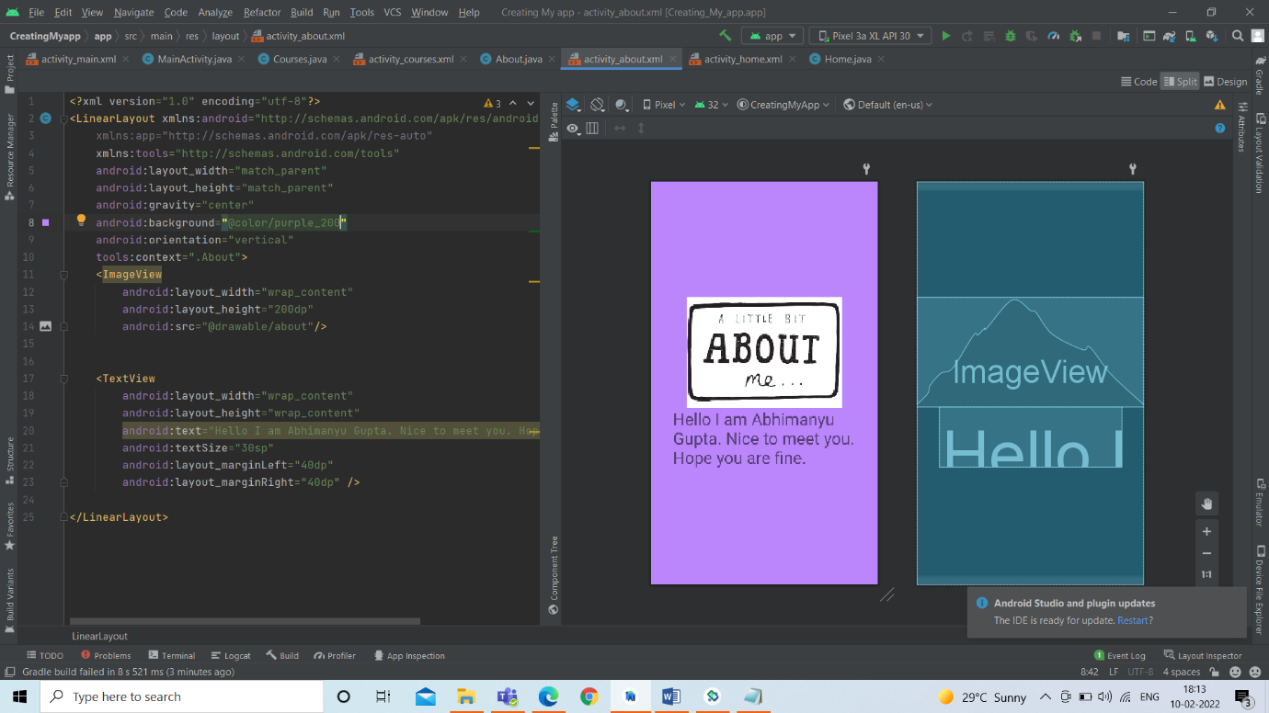

# CoursesC:\Users\Admin\Pictures\Screenshots\Screenshot (203).png

**Abhimanyu Gupta**

**J005**

**BTech. Data Science**

**Semester IV**

**70092000030**